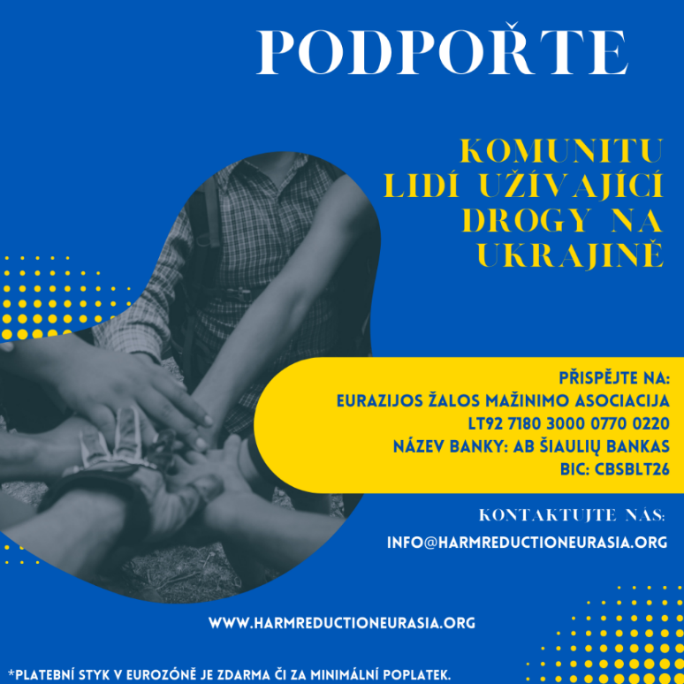

Emergency support to people who use drugs in Ukraine from SANANIM

Emergency situation
Number of refugees, people wo use drug is still unknown, but according to NGOs, a majority stayed in Ukraine. Main reasons are low-income, stigmatization, community is not mobile, most male are forbidden to leave the country. Shelters do not solve the housing problem as after a few months clients must find new place of residence, which is impossible without sources of income. Some people are moving back to their settlements, others have moved to the west where there is no frequent shelling. This makes difficult for the state logistics of providing medical and social assistance, including provision of OST.
Support from SANANIM
Thank to the active crowdfunding campaign by SANANIM EHRA received during 2022 in total - 2714 EURO. It was sent to Ukraine and distributed directly to community members who need this the most
What was the money spent on?
During the deployment of the full-scale war, the allocated funds were spent on a prompt allocation of 3,300 hryvnias (about 100 euros) in non-reimbursable, one-time cash payments. These funds could be promptly spent by people using drugs on evacuation, medical assistance, mobile communications, temporary shelter, food and clothing for them and their families. It has been possible to rapidly organize help to survive people who use drugs, who are still in urgent need of direct support in the Eastern and Central regions of Ukraine. Especially in Kharkiv, Luhansk and Zaporizhzhya oblasts in a situation of active hostilities. These regions have traditionally been considered depressed regions of the country and are now hotspots, occupied territories, with active hostilities taking place there. Ukrainian network of people using drugs VOLNA and Eurasian network of people using drugs in coordination defended names of people who need support, and in one-two days people received costs on their personal bank accounts.
Financial support from SANANIM went directly to 27 people from different cities in Ukraine where active hostilities are taking place: Chernihiv, Poltava, Mariupol, Kharkiv, Sloviansk, Sumy, Boyarka, the occupied territories of Berdyansk and Voznesensk, other cities.
One of the stories
Thanks to this direct emergency support families had possibility to safe their lives and to survive in the hard times. Here is one of the most dramatic stories:
Yevheniia and her daughter Nika lived in the small town of Rubizhne, in the Severodonetsk district of the Luhansk region of Ukraine. Yevheniia is on opioid substitution therapy and Nika has a very complex form of infantile cerebral palsy.
A titanic effort was made to evacuate Yevheniia and Nika from the occupied territory of Luhansk oblast, where Yevheniia miraculously survived rocket fire killed her neighbor Dmitriy. Literally, he was torn in half. Yevheniia was left without a home, OST medication, personal belongings, a wheelchair for a child with cerebral palsy. Oleksiy Kvitkovsky, an activist from VOLNA-Donbass the community of people who use drugs organization, immediately started looking for ways to get the mother and child into Ukrainian-controlled territory. It was very difficult, there were no evacuation buses, tickets for only carrier's buses were sold out in few minutes. In communicational vacuum Yevheniia was already on the verge of psychological breakdown, Alexei managed to organize two seats on a bus and raised funding from all-Ukrainian organization of People Who Use Drugs VOLNA, ENPUD and EHRA (direct support from this grant). In addition, great support was provided by people from key communities, who helped financially, gifted Nika a smartphone, the only entertainment during the war, helped to get to although the occupied but more or less peaceful town of Starobelsk and then helped to connect with international organizations for further assistance. Yevheniia then moved to Dnepr where she received OST for 15 days. All this time Alexei continued to look for an organization that could take care of the family outside of Ukraine. Through an international joint effort, the family ended up in the Netherlands. Nika and her mother Yevheniia are now living in a shelter for children with cerebral palsy in Hague, the Netherlands. Yevheniia is receiving take-home OST medication.

